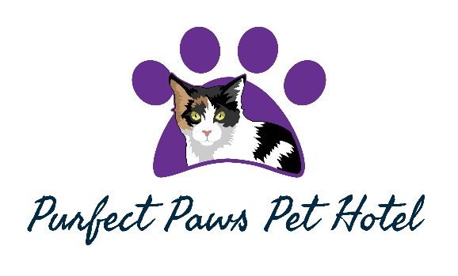
BOOKING FORM
The Paddock Stables, Woodlands of Durris, Aberdeenshire, AB31 6BD
Tel: 07830242300 or 07931821097
Email: info@purfectpawspethotel.co.uk

Opening hours: Weekdays 9.00am to 10.30am – 4.00pm to 5.30pm.
Weekends 9.30am to 11.00am

Please note: No booking will be confirmed until this form has been completed and returned with the required deposit of £20.00. Confirmation of your cats’ boarding will then be sent to you. The remaining balance of your cats’ boarding is then payable on arrival.

OWNERS’ NAME: .......................................................................................................................
OWNERS’ ADDRESS: .......................................................................................................................

………………………………………………………………………………

.......................................................................................................................

_{HOME TEL NO}: ………………………………… WORK TEL NO: …………………….……

MOBILE NO: …………………………………. EMERGENCY NO: …………………….…

EMAIL ADDRESS: ....................................................................................................................

VETS NAME/ADDRESS AND TEL NO:

..................................................................................................................................................
..................................................................................................................................................

REQUIRED DATES OF STAY

ARRIVAL DATE: …………………………….. DEPARTURE DATE: ……………………..……………
NOTE: The above dates will be chargeable unless we receive 14 days notice of cancellation.

DATE OF LAST VACCINATION: …………………………………………………………………...…….

IMPORTANT: We are unable to accept your cat unless an UP TO DATE FLU VACCINATION CERTIFICATE is shown on arrival.

I the owner of ……………………..have read and fully accept the Terms and Conditions of Purfect Paws Pet Hotel and understand all cats are accepted solely at owner’s risk. We accept no responsibility for accidents or illness and vet fees of your cat while in our care.

Owner’s signature: ………………………………………Date: ……………………………………………...

Breed of cat | Name & colour | Age | Sex | Any medical history we should be aware of:
Please ensure the last column of the above table is completed – (on a separate sheet if necessary). This information is very important should we have to call in a vet.

Does your cat/s have any history of cat flu in his/her past? - if so please give full details on a separate sheet YES/NO

PRICES - NB: All of our pens are family sized units so can house a family of cats.

Single cat per night: £11.00
Two cats per night sharing: £19.00
Family of cats [3 or more] sharing: £8.50 per cat per night.

Prices are fully inclusive of heating, wet and dry food, cat litter, bedding and daily management, cuddles and care.

PLEASE CHOOSE OTHER SERVICES REQUIRED

Any daily medication to be administered: (£1 per day for medication given) …………………………………….

E-mailed photos during stay - E-mail address……………...……………….……………….……………………..

Grooming £2 Per day (please supply your cat’s own brushes for this service) .. …………….……………………

Will you require: Collection Delivery
If collection / Delivery is required please specify Dates: …………………………………………….…………….

Will you be providing your cat’s own bed and toys? ………….................................................................................

PLEASE STATE BELOW YOUR CATS NORMAL EVERYDAY DIET TOGETHER WITH BRAND, QUANTITY AND TIMES PER DAY.

_____________________________________________________________________________________

______________________________________________________________________________________
PLEASE STATE YOUR CATS PREFERRED LITTER TYPE AND BRAND AND WHETHER THEY PREFER A HOODED OR OPEN TRAY.

______________________________________________________________________________________

PLEASE COMPLETE AND RETURN THIS FORM PRIOR TO YOUR CATS STAY WITH US.

WE DO NOT ACCEPT CHEQUES; WE ARE SORRY IF THIS CAUSES ANY INCONVENIENCE.

CASH PAYMENTS / BANK TRANSFERS ONLY.
Bank Details available on request.

A £20 deposit is required when booking to confirm your space.

Please sign and date below in acknowledgement of all of the above and Purfect Paws Pet Hotel’s Ts & Cs:

………………………………………………………………………….………..

WHEN ARRIVING OR COLLECTING YOUR CATS PLEASE NOTE OUR OPENING AND CLOSING TIMES BELOW.

MONDAY TO FRIDAY: 9.00am to 10.30am – 4.00pm to 5.30pm.
WEEKENDS: 9.30am to 11.00am.

WE ARE CLOSED ON CHRISTMAS DAY, BOXING DAY, NEW YEARS EVE AND NEW YEARS DAY.

